**STEPS FOR PROGRAMMING:-**

**Changing Z to C drive and directory to 8086**

z:\> mount c c:\

z:> c:

c:\> cd 8086

c:\8086>

Editor: This is used to open the editor for entering code

**Step1**: c:\8086> masm filename.asm

**Step2**: Linking: This is used to link the asm file to obj file

c:\8086> link filename.obj

**Step3**: The obj file is executed to generate the executable file

c:\8086> debug filename.exe

-g: This is used for entire program execution

-t: line by line execution

-u: unassemble the code

-q: To exit the debugger

-d<address of segment>:0

**Eg:** d 076b:0

Basic 8086 Program Structure:

Any 8086 program consists of two parts:

1. Directives (For the assembler)

2. Instruction and Values (For the compiler)

**PART-A: EXPERIMENTS ON 8086 MICROPROCESSOR**

**Experiment No. 01: Programs for 16-bit arithmetic operations using Various Addressing Modes.**

**A)** **ADDITION OF TWO 8BIT NNUMBERS:**

**REGISTERS USED:**AL, BL

S**OFTWARE USED:** MASM.

**PROGRAM:**

assume cs:code

code segment

start:mov al,02h

mov bl,03h

add al,bl

int 03h

code ends

end start

**OUTPUT:**

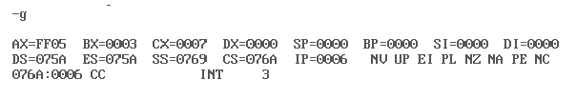

B) **SUBTRACTION OF TWO 8BIT NUMBERS:**

**REGISTERS USED:**AL, BL

S**OFTWARE USED:** MASM.

**PROGRAM:**

assume cs:code

code segment

start:mov al,05h

mov bl,03h

sub al,bl

int 03h

code ends

end start

**OUTPUT:**

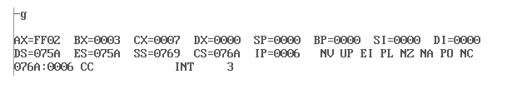

**C)** **MULTIPLICATION OF TWO 8BIT NUMBERS:**

**REGISTERS USED:**AL, BL

S**OFTWARE USED:** MASM.

**PROGRAM:**

assume cs:code

code segment

start:mov al,05h

mov bl,02h

mul bl

int 03h

code ends

end start

**OUTPUT:**

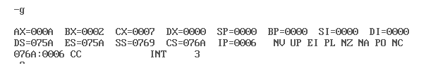

**D)** **DIVISION OF TWO 8BIT NUMBERS:**

**REGISTERS USED:**AL, BL

S**OFTWARE USED:** MASM.

**PROGRAM:**

assume cs:code

code segment

start:mov al,7h

mov bl,2h

div bl

int 03h

code ends

end start

**OUTPUT:**

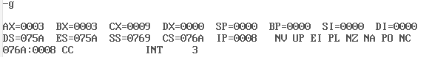

**E)** **ADDITION OF TWO 16BIT NNUMBERS:**

**REGISTERS USED:**AX, BX

S**OFTWARE USED:** MASM.

**PROGRAM:**

assume cs:code

code segment

start:mov ax,2345h

mov bx,5623h

add ax,bx

int 03h

code ends

end start

**OUTPUT:**

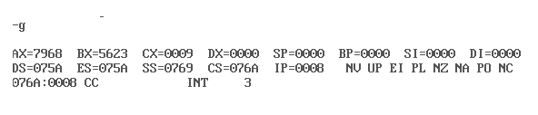

**F)** **SUBTRACTION OF TWO 16BIT NUMBERS:**

**REGISTERS USED:**AX, BX

S**OFTWARE USED:** MASM.

**PROGRAM:**

assume cs:code

code segment

start:mov ax,7896h

mov bx,2345h

sub ax,bx

int 03h

code ends

end start

**OUTPUT:**

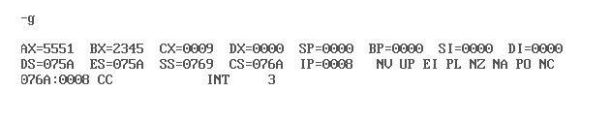

G) **MULTIPLICATION OF TWO 16BIT NUMBERS:**

**REGISTERS USED:**AX,BX

S**OFTWARE USED:** MASM.

**PROGRAM:**

assume cs:code

code segment

start:mov ax,2345h

mov bx,3456h

mul bx

int 03h

code ends

end start

**OUTPUT:**

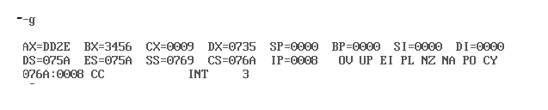

**H)** **DIVISION OF TWO 16BIT NUMBERS:**

**REGISTERS USED:**AX, BX

S**OFTWARE USED:** MASM.

assume cs:code

code segment

start:mov ax,4000h

mov bx,2000h

div ax

int 03h

code ends

end start

**OUTPUT:**

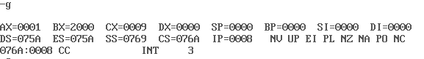

**ADDITION OF NUMBERS USING ADDRESSING MODES:**

**REGISTERS USED:**AX,BX,SI,DI

S**OFTWARE USED:** MASM.

**PROGRAM:**

assume cs:code,ds:data

data segment

input dw 0F232h,4535h

output dw 0000h

data ends

code segment

start:mov ax,data

mov ds,ax

mov si,offset input

mov di,offset output

mov ax,[si]

add si,0002h

mov bx,[si]

add ax,bx

mov [di],ax

int 03h

code ends

end start

**OUTPUT:**



**Experiment No. 02: Program for sorting an array for 8086.**

**A)SORTING AN ARRAY OF UNSIGNED INTEGERS IN ASCENDING ORDER**

**REGISTERS USED:**AX, DS, SI, CX, DX

S**OFTWARE USED:** MASM.

**PROGRAM:**

assume cs:code,ds:data

data segment

arr1 db 53h,25h,19h,02h,29h

count equ 04h

data ends

code segment

start:mov ax,data

mov ds,ax

mov dx,count

back0:mov cx,count

mov si,offset arr1

bacl1:mov al,[si]

cmp al,[si+1]

jb next

xchg [si+1],al

xchg [si],al

next:inc si

loop back1

dec dx

jnz back0

int 03h

code ends

end start

**OUTPUT:**

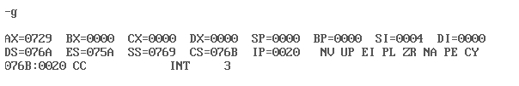

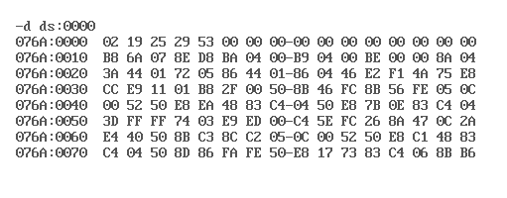

**B) SORTING AN ARRAY OF UNSIGNED INTEGERS IN DESCENDING ORDER:**

**REGISTERS USED:**AX, DS, SI, CX, DX

S**OFTWARE USED:** MASM.

**PROGRAM:**

assume cs:code,ds:data

data segment

arr1 db 57h,26h,78h,98h,67h

count equ 04h

data ends

code segment

start:mov ax,data

mov ds,ax

mov dx,count

back0:mov cx,count

mov si,offset arr1

back1:mov al,[si]

cmp al,[si+1]

ja next

xchg [si+1],al

xchg [si],al

next:inc si

loop back1

dec dx

jnz back0

int 03h

code ends

end start

**OUTPUT:**

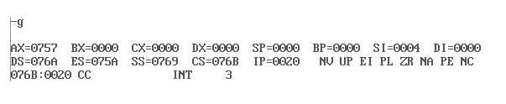

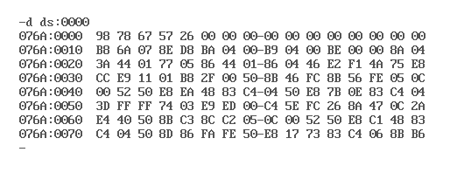

**C) SORTING AN ARRAY USING DATAWORD:**

**REGISTERS USED:**AX, DS, SI, CX, DX

S**OFTWARE USED:** MASM.

**PROGRAM:**

assume cs:code,ds:data

data segment

arr1 dw 3242h,8567h,7865h,4536h,9867h

count equ 0004h

data ends

code segment

start:mov ax,data

mov ds,ax

mov dx,count

back0:mov cx,count

mov si,offset arr1

back1:mov ax,[si]

cmp ax,[si+2]

jb next

xchg [si+2],ax

xchg [si],ax

next:add si,0002h

loop back1

dec dx

jnz back0

int 03h

code ends

end start

**OUTPUT:**

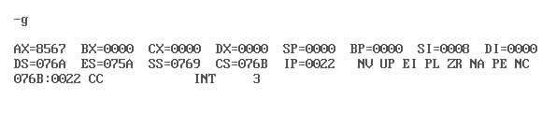

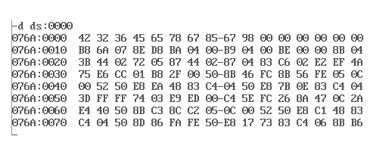

**D) SORTING AN ARRAY OF SIGNED INTEGERS IN ASCENDING ORDER:**

**REGISTERS USED:**AX, DS, SI, CX, DX

S**OFTWARE USED:** MASM.

**PROGRAM:**

assume cs:code,ds:data

data segment

arr1 db +53h,-25h,-19h,+02h

count equ 04h

data ends

code segment

start:mov ax,data

mov ds,ax

mov dx,count-1

back0:mov cx,dx

mov si,offset arr1

back1:mov al,[si]

cmp al,[si+1]

jl next

xchg [si+1],al

xchg [si],al

next:inc si

loop back1

dec dx

jnz back0

int 03h

code ends

end start

**OUTPUT:**

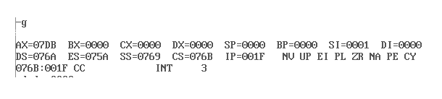

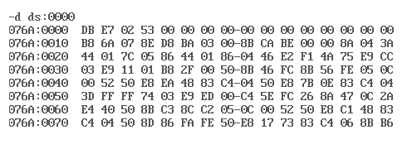

**E) SORTING AN ARRAY OF SIGNED INTEGERS IN DESCENDING ORDER:**

**REGISTERS USED:**AX, DS, SI, CX, DX

S**OFTWARE USED:** MASM.

**PROGRAM:**

assume cs:code,ds:data

data segment

arr db +53h,-25h,-19h,+02h

count equ 04h

data ends

code segment

start:mov ax,data

mov ds,ax

mov dx,count-1

back0:mov cx,dx

mov si,offset arr

back1:mov al,[si]

cmp al,[si+1]

jg next

xchg [si+1],al

xchg [si],al

next:inc si

loop back1

dec dx

jnz back0

int 03h

code ends

end start

**OUTPUT:**

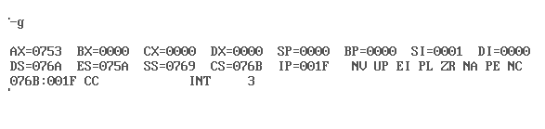

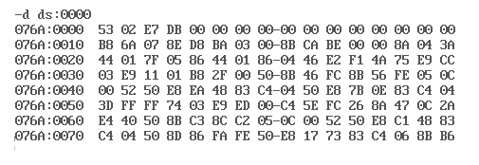

**Experiment No. 03: Program for searching for a number or character in a string for 8086**

**A) PROGRAM TO FIND WHETHER A CHARACTER IS PRESENT IN STRING OR NOT**

**REGISTERS USED:**AX, DS, SI, CX, DX

S**OFTWARE USED:** MASM.

**PROGRAM:**

assume cs:code,ds:data

data segment

str1 db "VNRVJIET$"

str2 db "character is found$"

str3 db "character is not found$"

data ends

code segment

start:mov ax,data

mov ds,ax

mov si,offset str1

mov cx,08h

mov al,"J"

back:cmp al,[si]

je last1

mov dx,offset str2

mov ah,09h

int 21h

jmp last2

last1:mov dx,offset str3

mov ah,09h

int 21h

last2:int 3h

code ends

end start

**OUTPUT:**

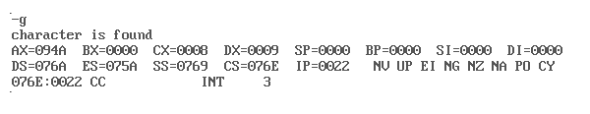

**Experiment No. 04: Program for string manipulations for 8086**

**A) PROGRAM TO MOVE A SOURCE STRING TO DESTINATION**

**REGISTERS USED:**AX, DS, SI, CX, ES, DI

S**OFTWARE USED:** MASM.

**PROGRAM:**

assume cs:code,ds:data,es:extra

data segment

str1 db "VNRVJIETECE$"

len1 dw($-str1)

data ends

extra segment

str db 10 dup(?)

extra ends

code segment

start:mov ax,data

mov ds,ax

mov ax,extra

mov es,ax

cld

mov si,offset str1

mov di,offset str

mov cx,len1

dec cx

rep movsb

int 3h

code ends

end start

**OUTPUT:**

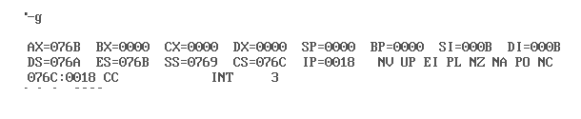

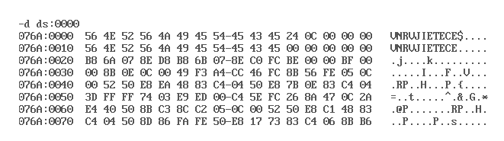

**B) PROGRAM TO CHECK WHETHER A CHARACTER IS PRESENT IN STRING OR NOT**

**REGISTERS USED:**AX, DS, ES, SI, CX, DI

S**OFTWARE USED:** MASM.

**PROGRAM:**

assume cs:code,ds:data,es:extra

data segment

str2 db "character is available$"

str3 db "character is not available$"

data ends

extra segment

str1 db "VNRVJIET$"

extra ends

code segment

start:mov ax,data

mov ds,ax

mov ax,extra

mov es,ax

mov di,offset str1

mov al,'E'

mov cx,0008h

CLD

REPNE SCASB

JZ next1

next2:mov dx,offset str3

mov ah,09h

int 21h

jmp next3

next1:mov dx,offset str2

mov ah,09h

int 21h

next3:int 03h

code ends

end start

**OUTPUT:**

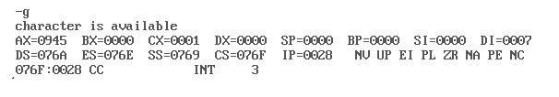

**C) PROGRAM TO CONCATENATE TWO STRINGS**

**REGISTERS USED:**AX, DS, ES, SI, CX, DI

S**OFTWARE USED:** MASM.

**PROGRAM:**

assume cs:code,ds:data,es:extra

data segment

str1 db "VNRVJIET$"

len1 dw($-str1)

str2 db "ELECTRONICS$"

len2 dw($-str2)

data ends

extra segment

str db 15 dup(?)

extra ends

code segment

start:mov ax,data

mov ds,ax

mov ax,extra

mov es,ax

cld

mov si,offset str1

mov di,offset str

mov cx,len1

dec cx

rep movsb

mov si,offset str2

mov cx,len2

rep movsb

int 3h

code ends

end start

**OUTPUT:**

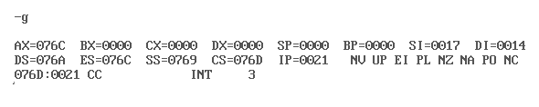

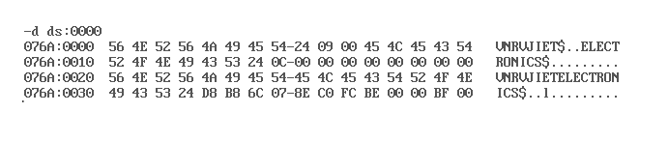

**D) PROGRAM TO REVERSE A STRING.**

**REGISTERS USED:**AX, DS, SI, CX, DI, ES

S**OFTWARE USED:** MASM.

**PROGRAM:**

assume cs:code,ds:data,es:extra

data segment

str1 db "VNRVJIET$"

len1 dw($-str1)

data ends

extra segment

str db 15 dup(?)

extra ends

code segment

start:mov ax,data

mov ds,ax

mov ax,extra

mov es,ax

cld

mov si,offset str1

mov di,offset str

mov cx,len1

dec cx

add di,cx

mov byte ptr es:[di],"$"

dec di

back:cld

lod sb

std

sto sb

loop back

int 3h

code ends

end start

**OUTPUT:**

**E) PROGRAM TO COMPARE TWO STRINGS.**

**REGISTERS USED:** AX, DS, SI, CX, DI, ES

S**OFTWARE USED:** MASM.

**PROGRAM:**

assume cs:code,ds:data

data segment

str3 db 'strings are equal$'

str4 db 'strings are not equal$'

str1 db 'VNRVJIET$'

data ends

extra segment

str2 db 'VNRVJEET$'

extra ends

code segment

start:mov ax,data

mov ds,ax

mov ax,extra

mov es,ax

mov di,offset str2

mov si,offset str1

mov cx,0008h

cld

repe cmpsb

jz next1

next2:mov dx,offset str4

mov ah,09h

int 21h

jmp next3

next1:mov dx,offset str3

mov ah,09h

int 21h

next3:int 3h

code ends

end start

**OUTPUT**:

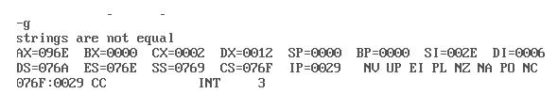

**Experiment No. 05: Program to define and call a subroutine which calculates the average of three numbers**

**REGISTERS USED:**AX, DS, SI, BL, DI

S**OFTWARE USED:** MASM.

**PROGRAM**

assume cs:code,ds:data

data segment

arr1 db 05h,06h,07h

avg db 03h

data ends

code segment

start:mov ax,data

mov ds,ax

mov si,offset arr1

mov di,offset avg

call average

int 03h

average:mov cx,02h

xor ax,ax

back:mov al,[si]

add [si+1],al

jnc next

inc ah

next:inc si

loop back

mov al,[si]

mov bl,[di]

div bl

ret

code ends

**OUTPUT**:

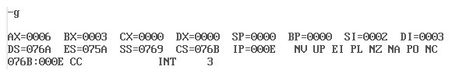

**INTERFACING MICROPROCESSOR WITH ADC, DAC, STEPPER MOTOR:**

**STEPS FOR EXCEUTION:**

C:\masm 123>masm filename

C:\masm 123>link filename

C:\masm 123>promview

**PROMVIEW SOFTWARE:**

Select:

**1)File operations :**Select Format

Press 0-Binary (EXE)

**2)File operations:**Read

Filename.exe:

Default 0000

**3)RAM operation:**View

Starting address:starting address+200

:4200

Ending address :4300

Press ESC key

**4)File operation:**Select format

Press 1:intel hex

**5)File operation:** Write

RAM starting address:4200

RAM ending address:4230

Enter file name:ADC.Hex

Exit: Back to DOS

Are you sure(Y/N):Y

Are you saving file(Y/N):Y

C:\masm 123>edit filename. Hex

**Post prom view steps:**

C:\masm 123>tc serial 1

Press ‘S’ in kit keyword

UIK-86

Type-‘L’ OFFSET=0

Enter filename: adc.hex

**Running the program:**

The program can be run using two commands.

i)D4200: Unassembles and displays line wise code.

ii)G4200: It is used to run the program.

**ADC INTERFACING:**

**In interfacing an ADC to the 8086 microprocessor in lab,we have a fixed set of port address.**

PA: FF50H PC: FF54H

PB: FF52H CONTROL WORD REGISTER: FF56H

PORTA-Input port

PORTC Upper: SOC Signal

**INTERFACING ADC WITH 8086:**

**REGISTERS USED:**AL,DX,CX

S**OFTWARE USED:** MASM, promview

**PROGRAM:**

code segment

assume cs:code

org 2000h

mov dx,0ff56h

mov al,90h

out dx,al

mov dx,0ff54h

mov al,0ffh

out dx,al

mov al,00h

out dx,al

mov al,0ffh

out dx,al

call delay

call delay

mov dx,0ff50h

in al,dx

int 3h

delay:mov cx,0ffffh

loop1:nop

nop

dec cx

jnz loop1

ret

code ends

end

**OUTPUT:**

|  |  |
| --- | --- |
| **ANALOG I/P** | **DIGITAL O/P** |
| 1.2 | 42 |
| 1.7 | 5C |
| 2.1 | 71 |
| 2.5 | 87 |

**INTERFACING DAC WITH 8086:**

**i)PROGRAM TO GENERATE A SQUARE WAVEFORM:**

**REGISTERS USED:**AL,DX,CX

S**OFTWARE USED:** MASM,promview

**PROGRAM:**

code segment

assume cs:code

org 2000h

mov dx,0ff56h

mov al,80h

out dx,al

mov dx,0ff52h

next:mov al,0ffh

out dx,al

call delay

mov al,00h

out dx,al

call delay

jmp next

delay:mov cx,07ffh

x:nop

nop

dec cx

jnz x

ret

code ends

end start

**OUTPUT:**

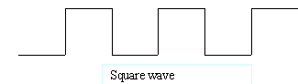

**ii)PROGRAM TO GENERATE A RAMP WAVEFORM:**

**REGISTERS USED:**AL,DX,CX

S**OFTWARE USED:** MASM,promview

**PROGRAM:**

code segment

assume cs:code

org 2000h

mov dx,0ff56h

mov al,80h

out dx,al

mov dx,0ff52h

mov al,00h

next:out dx,al

inc al

jmp next

int 3h

code ends

end start

**OUTPUT:**

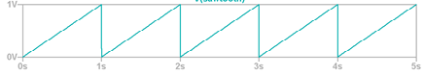

**INTERFACING STEPPER MOTOR WITH 8086**

**REGISTERS USED:**AL, DX, CX

S**OFTWARE USED:** MASM, promview

**PROGRAM:**

mov dx,ff26h

mov al,80h

out dx,al

Step:mov dx,0ff20h

mov al,80h

out dx,al

call delay

mov al,A0

out dx,al

call delay

mov al,E0

out dx,al

call delay

mov al,C0

out dx,al

call delay

jmp step

delay:mov bx,0010

last:mov al,ff

last1:nop

nop

nop

nop

dec al

jnz last1

dec bx

jnz last

ret

**OUTPUT:**

**PART B: EXPERIMENTS ON ARM DEVELOPMENT BOARDS:**

**Experiment No. 01: Programs to perform arithmetic operations**

**PROGRAM:**

;;; Directives

STACK_ADDR_123G EQU 0x20008000

PRESERVE8

THUMB

; Vector Table Mapped to Address 0 at Reset

; Linker requires __Vectors to be exported

AREA RESET, DATA, READONLY

EXPORT __Vectors

__Vectors

DCD 0x20001000 ; stack pointer value when stack is empty

;The processor uses a full descending stack.

;This means the stack pointer holds the address of the last

;stacked item in memory. When the processor pushes a new item

;onto the stack, it decrements the stack pointer and then

;writes the item to the new memory location.

DCD Reset_Handler ; reset vector

ALIGN

; The program

; Linker requires Reset_Handler

AREA MYCODE, CODE, READONLY

ENTRY

EXPORT Reset_Handler

Reset_Handler

;;;;;;;;;;User Code Starts from the next line;;;;;;;;;;;;

MOV R0, #4

MOV R1, #2

START

ADD R3, R1, R0

MUL R2,R1,R0

SUB R4,R0,R1

UDIV R5,R0,R1

B START

END; End of the program

**OUTPUT:**

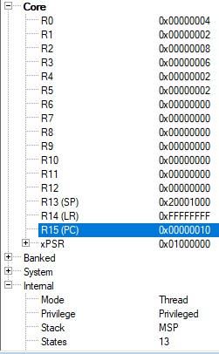

**Experiment No. 02: Control ON/OFF of LEDs using switches involving delays.**

**PROGRAM:**

#define SYSCTL_RCGCGPIO_R (*(( volatile unsigned long *)0x400FE608 ) )

#define GPIO_PORTF_DATA_R (*(( volatile unsigned long *)0x40025038 ) )

#define GPIO_PORTF_DIR_R (*(( volatile unsigned long *)0x40025400 ) )

#define GPIO_PORTF_DEN_R (*(( volatile unsigned long *)0x4002551C ) )

#define GPIO_PORTF_CLK_EN 0x20

#define GPIO_PORTF_PIN1_EN 0x02

#define LED_ON1 0x02

#define GPIO_PORTF_PIN2_EN 0x04

#define LED_ON2 0x04

#define GPIO_PORTF_PIN3_EN 0x08

#define LED_ON3 0x08

#define DELAY_VALUE 1000000

unsigned long j=0;

void Delay(void){

for (j=0; j<DELAY_VALUE ; j++);

}

int main ( void )

{

volatile unsigned long ulLoop ;

SYSCTL_RCGCGPIO_R |= GPIO_PORTF_CLK_EN ;

ulLoop = SYSCTL_RCGCGPIO_R;

GPIO_PORTF_DIR_R |= GPIO_PORTF_PIN1_EN ;

GPIO_PORTF_DEN_R |= GPIO_PORTF_PIN1_EN ;

GPIO_PORTF_DIR_R |= GPIO_PORTF_PIN2_EN ;

GPIO_PORTF_DEN_R |= GPIO_PORTF_PIN2_EN ;

GPIO_PORTF_DIR_R |= GPIO_PORTF_PIN3_EN ;

GPIO_PORTF_DEN_R |= GPIO_PORTF_PIN3_EN ;

while (1)

{

GPIO_PORTF_DATA_R &= LED_ON3;

GPIO_PORTF_DATA_R &= LED_ON2;

GPIO_PORTF_DATA_R |= LED_ON1;

Delay();

GPIO_PORTF_DATA_R &= LED_ON1;

GPIO_PORTF_DATA_R &= LED_ON2;

GPIO_PORTF_DATA_R |= LED_ON3;

Delay();

GPIO_PORTF_DATA_R &= LED_ON3;

GPIO_PORTF_DATA_R &= LED_ON1;

GPIO_PORTF_DATA_R |= LED_ON2;

Delay();

}

}

**OUTPUT:**

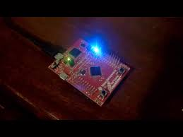

**Experiment No. 03: Controlling an LED using switch by polling method/Interrupt method.**

**i)INTERRUPT METHOD:**

**PROGRAM:**

#include "TM4C123.h"

int main(void)

{

SYSCTL->RCGCGPIO |= (1<<5);

GPIOF->LOCK = 0x4C4F434B;

GPIOF->CR = 0x01**;**

GPIOF->LOCK = 0;

GPIOF->DIR &= ~(1<<4)|~(1<<0);

GPIOF->DIR |= (1<<3);

GPIOF->DEN |= (1<<4)|(1<<3)|(1<<0**);**

GPIOF->PUR |= (1<<4)|(1<<0);

GPIOF->IS &= ~(1<<4)|~(1<<0);

GPIOF->IBE &=~(1<<4)|~(1<<0);

GPIOF->IEV &= ~(1<<4)|~(1<<0);

GPIOF->ICR |= (1<<4)|(1<<0);

GPIOF->IM |= (1<<4)|(1<<0);

NVIC->IP[30] = 3 << 5;

NVIC->ISER[0] |= (1<<30);

while(1)

{

// do nothing and wait for the interrupt to occur

}

}

void GPIOF_Handler(void)

{

if (GPIOF->MIS & 0x10)

{

GPIOF->DATA |= (1<<3);

GPIOF->ICR |= 0x10;

}

else if (GPIOF->MIS & 0x01

{

GPIOF->DATA &= ~0x08;

GPIOF->ICR |= 0x01**;**

**\*/**

}

}

**ii)POLLING METHOD:**

**PROGRAM:**

#include "TM4C123GH6PM.h"

int main(void)

{

unsigned int state;

SYSCTL->RCGCGPIO |= 0x20**;**

GPIOF->LOCK = 0x4C4F434B;

GPIOF->CR = 0x01

GPIOF->PUR |= 0x10;

GPIOF->DIR |= 0x02;

GPIOF->DEN |= 0x12;

while(1)

{

state = GPIOF->DATA & 0x10;

GPIOF->DATA = (~state>>3);

}

}

**OUTPUT:**

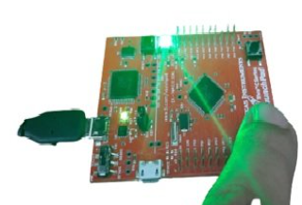

**Experiment No. 04** **: Implementation of PWM to change duty cycle.**

**PROGRAM:**

#include "TM4C123GH6PM.h"

int main(void)

{

void Delay_ms(int n);

int duty_cycle = 4999;

SYSCTL->RCGCPWM |= 2;

SYSCTL->RCGCGPIO |= 0x20;

SYSCTL->RCC |= (1<<20);

SYSCTL->RCC |= 0x000E0000;

GPIOF->AFSEL |= (1<<2);

GPIOF->PCTL &= ~0x00000F00;

GPIOF->PCTL |= 0x00000500;

GPIOF->DEN |= (1<<2);

PWM1->_3_CTL &= ~(1<<0);

PWM1->_3_CTL &= ~(1<<1);

PWM1->_3_GENA = 0x0000008C;

PWM1->_3_LOAD = 5000;

PWM1->_3_CMPA = 4999;

PWM1->_3_CTL = 1;

PWM1->ENABLE = 0x40;

while(1)

{

duty_cycle = duty_cycle - 10;

if (duty_cycle <= 0)

duty_cycle = 5000;

PWM1->_3_CMPA = duty_cycle;

Delay_ms(100);

}

}

void Delay_ms(int time_ms){

int i, j;

for(i = 0 ; i < time_ms; i++)

for(j = 0; j < 3180; j++)

{}

}

void SystemInit(void)

{

SCB->CPACR |= 0x00f00000;

}

**OUTPUT:**

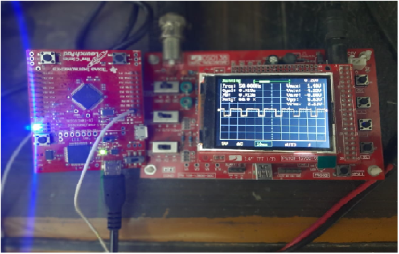

**Experiment No. 05: Communication through UART**

**UART TRANSMITTER**

**PROGRAM:**

#include "TM4C123.h"

void Delay(unsigned long counter);

char UART5_Receiver(void);

void UART5_Transmitter(char data);

int main(void)

{

SYSCTL->RCGCUART |= 0x20;

SYSCTL->RCGCGPIO |= 0x10;

Delay(1);

UART5->CTL = 0;

UART5->IBRD = 104;

UART5->FBRD = 11;

UART5->CC = 0;

UART5->LCRH = 0x60;

UART5->CTL = 0x301;

GPIOE->DEN = 0x30;

GPIOE->AFSEL = 0x30;

GPIOE->AMSEL = 0;

GPIOE->PCTL = 0x00110000;

Delay(1);

while(1)

{

UART5_Transmitter('H');

UART5_Transmitter('E');

UART5_Transmitter('L');

UART5_Transmitter('L');

UART5_Transmitter('O');

UART5_Transmitter('\n');

}

}

void UART5_Transmitter(char data)

{

while((UART5->FR & 0x20) != 0);

UART5->DR = data;

}

void Delay(unsigned long counter)

{

unsigned long i = 0;

for(i=0; i< counter; i++);

}

**OUTPUT:**

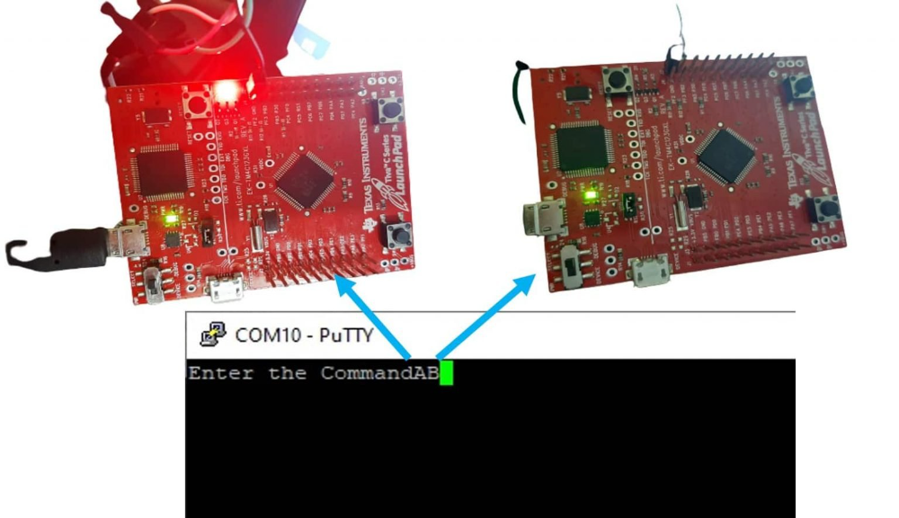

**UART RECEIVER**

**PROGRAM:**

#include "TM4C123.h"

#include <stdint.h>

#include <stdlib.h>

void Delay(unsigned long counter);

char UART5_Receiver(void);

void UART5_Transmitter(unsigned char data);

void printstring(char *str);

int main(void)

{

SYSCTL->RCGCUART |= 0x20;

SYSCTL->RCGCGPIO |= 0x10;

Delay(1);

UART5->CTL = 0;

UART5->IBRD = 104;

UART5->FBRD = 11;

UART5->CC = 0;

UART5->LCRH = 0x60;

UART5->CTL = 0x301;

GPIOE->DEN = 0x30;

GPIOE->AFSEL = 0x30;

GPIOE->AMSEL = 0;

GPIOE->PCTL = 0x00110000;

Delay(1);

printstring("Hello World \n");

Delay(10);

while(1)

{

char c = UART5_Receiver();

UART5_Transmitter(c);

}

}

char UART5_Receiver(void)

{

char data;

while((UART5->FR & (1<<4)) != 0);

data = UART5->DR ;

return (unsigned char) data;

}

void UART5_Transmitter(unsigned char data)

{

while((UART5->FR & (1<<5)) != 0);

UART5->DR = data;

}

void printstring(char *str)

{

while(*str)

{

UART5_Transmitter(*(str++));

}

}

void Delay(unsigned long counter)

{

unsigned long i = 0;

for(i=0; i< counter; i++);

}

void SystemInit(void)

{

__disable_irq();

SCB->CPACR |= 0x00F00000;

}

**OUTPUT:**

